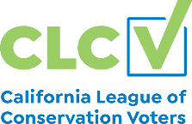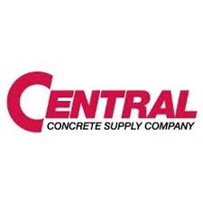nn



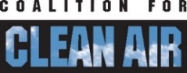







June 1, 2022

The Honorable Cottie Petrie-Norris, Chair

Assembly Accountability and Administrative Review Committee

1020 N Street, Room 357

Sacramento, CA 95814

**Re: SB 778 (Becker) Buy Clean Concrete – SUPPORT**

Dear Assembly Member Petrie-Norris and Committee Members:

As organizations and industry leaders committed to reducing the carbon footprint of our built environment, we are pleased to support SB 778 by Senator Becker. As amended on May 24, SB 778 will add concrete to California’s “Buy Clean” program, mobilizing the state’s purchasing power to drive innovation in reducing emissions from the world’s most consumed material.

Concrete is vital to building roads, bridges, and other essential infrastructure, but the manufacture of cement (the “glue” in concrete) is also a major source of greenhouse gas emissions and local air pollution. Cement production and concrete use is expected to grow by as much as 40 percent in California by 2040. To avoid a corresponding spike in emissions, the state needs to advance polices like SB 778 what will grow demand for low-carbon concrete.

SB 778 builds on work underway at Caltrans, the High-Speed Rail Authority, and local governments to require disclosure of the embodied greenhouse gas emissions of concrete products used in state public works projects, and over time set minimum standards to align state purchasing with California’s climate commitments. It follows on the heels of the Biden Administration’s recently announced low-embodied carbon standards for concrete used in federal projects funded by the General Services Administration, and procurement standards for low carbon concrete being developed in other leading states.

Passing SB 778 will reclaim California’s leadership and instill a framework for continual improvement to extend our competitive advantage in clean tech into the industrial sector. As California embarks on major infrastructure development, SB 778 will ensure the state both leads by example and sends a strong market signal to hasten the transition to cleaner concrete.

We respectfully request an AYE vote.

Sincerely,

|  |  |
| --- | --- |
| Alex Jackson,  Senior Attorney  Natural Resources Defense Council | Herb Burton  Regional Vice President & General Manager  Central Concrete |
| Mark Christian  Director of Government Relations  American Institute of Architects, California  Ellie Cohen  CEO  The Climate Center | Bill Magavern  Policy Director  Coalition for Clean Air  Jason Barbose  Senior Policy Manager, Western States  Union of Concerned Scientists |
| Andy Wunder  Western States Advocate  E2, Environmental Entrepreneurs | Daniel Barad  Campaign Representative  Sierra Club CA |
| Rory Jacobson  Senior Policy Advisor  Carbon 180  Justin Malan  U.S. Green Building Council – L.A. | Melissa Romero  Legislative Affairs Manager  California Environmental Voters  Arnold Sowell, Jr.  Executive Director, NextGen California |
| Laura Berland-Shane  Vice President, Government Affairs  Blue Planet |  |