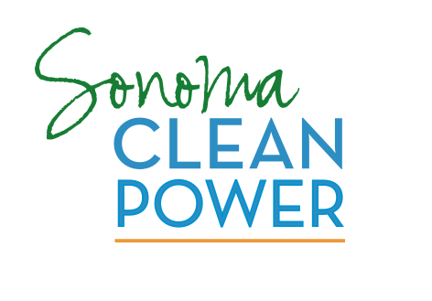
Sabta Riose

Sonoma Clean Power Petition
Sonoma Clean Power is a local program that will buy and generate electricity for businesses and residents. It will bring consumer choice into the electricity sector for the first time in a long time. It also promises to boost economic development while decreasing greenhouse gas emissions. Cities must decide by June 30 whether to participate.

Dear City Council Members: Thank you for considering Sonoma Clean Power. This program will give residents and businesses the choice – PG&E or Sonoma Clean Power. If you do not adopt a resolution, we will not have a choice.

Please give us the choice! Please vote “yes” for Sonoma Clean Power.

Name ___________________________________________________________________________
Address _________________________________________City_____________________________
Phone _________________________________ Email ____________________________________
Name ___________________________________________________________________________
Address _________________________________________City_____________________________
Phone _________________________________ Email ____________________________________
Name ___________________________________________________________________________
Address _________________________________________City_____________________________
Phone _________________________________ Email ____________________________________
Name ___________________________________________________________________________
Address _________________________________________City_____________________________
Phone _________________________________ Email ____________________________________
Name ___________________________________________________________________________
Address _________________________________________City_____________________________
Phone _________________________________ Email ____________________________________
Name ___________________________________________________________________________
Address _________________________________________City_____________________________
Phone _________________________________ Email ____________________________________

Please return this petition to the Climate Protection Campaign: P.O. Box 3785, Santa Rosa, CA 95402

